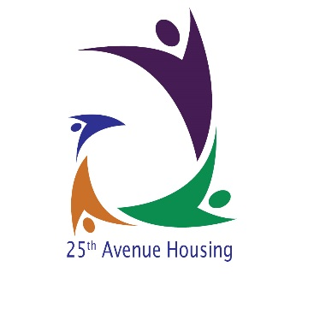

TO WHOM IT MAY CONCERN

RE: Accommodation Referral Application to Twenty Fifth Avenue Housing Ltd.

We have received your application form for accommodation placement with our service. We will like to invite you for an assessment interview on:

Date:
Venue: 3, Wellington Street, Woolwich, London, SE18 6NY
Time: 2-4pm

Could you please ensure that you bring the following document with you to the interview?

- Proof of Identification-ID e.g. Travel Passport/immigration status letter/Driving Licence
- Proof of Income e.g. Letter confirming benefits received within the last three months
- Proof of National Insurance Number-NI NO
- Proof of savings e.g. up to date bank account(s)/building society statements or post office account within the last 3 months

We are happy for you to be accompanied by the person who referred you example could be your social worker, homeless person staff, probation officer/CPN/parent if you so wish. Could you please contact our Team of Housing Officers on 02088548854 to confirm your attendance?
After this meeting we will be able to make final decision about whether our organisation is able to offer you the service that you require.
I look forward to meeting with you

Yours Sincerely

Magdalene Sarpei
Administrative Officer

